
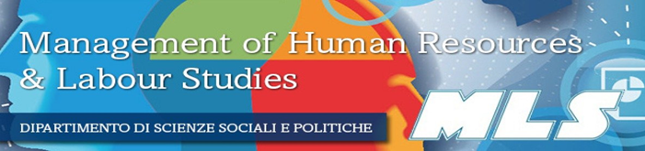

WORKSHOP 2026

From Lean to Agile: New approaches and strategies for an unpredictable present

Facilitator: Marco Camerini, HR consultant, trainer and executive coach

INTRODUCTION
Agile principles were initially meant for Software Development. In few years they spread across several fields and industries as a possible response to a complex fast-moving scenario. Today “Agile” seems to be “suitable” for every aspect of human endeavor: Agile leadership, Agile Business, Agile PM, Agile Organization, … Is it really like this? And why? Understanding the history of these ideas and their development is important to understand current trends and business strategies implemented by companies to face the transition from old to new (often disruptive) models.

LEARNING OUTCOMES
This workshop aims to provide a general understanding of the basic principles of Lean and Agile approach, their history and practical application.
In particular, participants will acquire
- basic knowledge of the history of Agile approach, concepts, tools and terminology
- insights about how to introduce this model within an organization
- awareness of Agile opportunities and challenges through the analysis of case histories

PROGRAMME DETAILS
- What is “Agile”? A short history of a movement
- Why the dominant paradigm is not suitable anymore for today challenges?
- Lean thinking: history and basic concepts
- From “push to pull”: what’s new?
- Some Agile tools and techniques
- Learning “to read” the organization with different glasses
- What are the potential impacts for all the stakeholders?

WHO IS IT FOR?

Target: students of the first year.
Maximum number of participants to the workshop: 15
In the event that the number of students enrolling in the course surpasses the number of places available (15), precedence will be given to the order in which enrollment requests have been received.

METHODOLOGY

During the workshop there will be presentations, case studies, discussions, learning games, group activities and interviews to selected managers applying Lean or Agile in their companies.
All topics will be presented with a pragmatic approach, providing several examples and exercises.

FINAL EVALUATION

At the end of the workshop the students have to write an individual report and a group presentation.
Required minimum attendance: 80% of the meetings
3 credits will be provided only to students who, beside the minimum attendance, will present the required reports and papers.
SCHEDULE (to be confirmed):
Monday 2nd February 16.30- 19.00
Monday 9th February 16-30-19.00
Monday 16thFebruary 16.30- 19.00
Monday 23rdFebruary 16.30- 19.00
Monday 9th March 16.30- 19.00
Monday 9^{23rd} March 16.30- 19.00
+ company interviews (TBD)

HOW TO APPLY

Send an email to the trainer within the 22nd January 2026
camerini@gso.it
OBJ: Agile Workshop 2026
Info MUST be included in the mail:
- ID (matricola)
- Name/ Surname
- Degree Course
- Year
- Reasons why you want to attend this seminar

